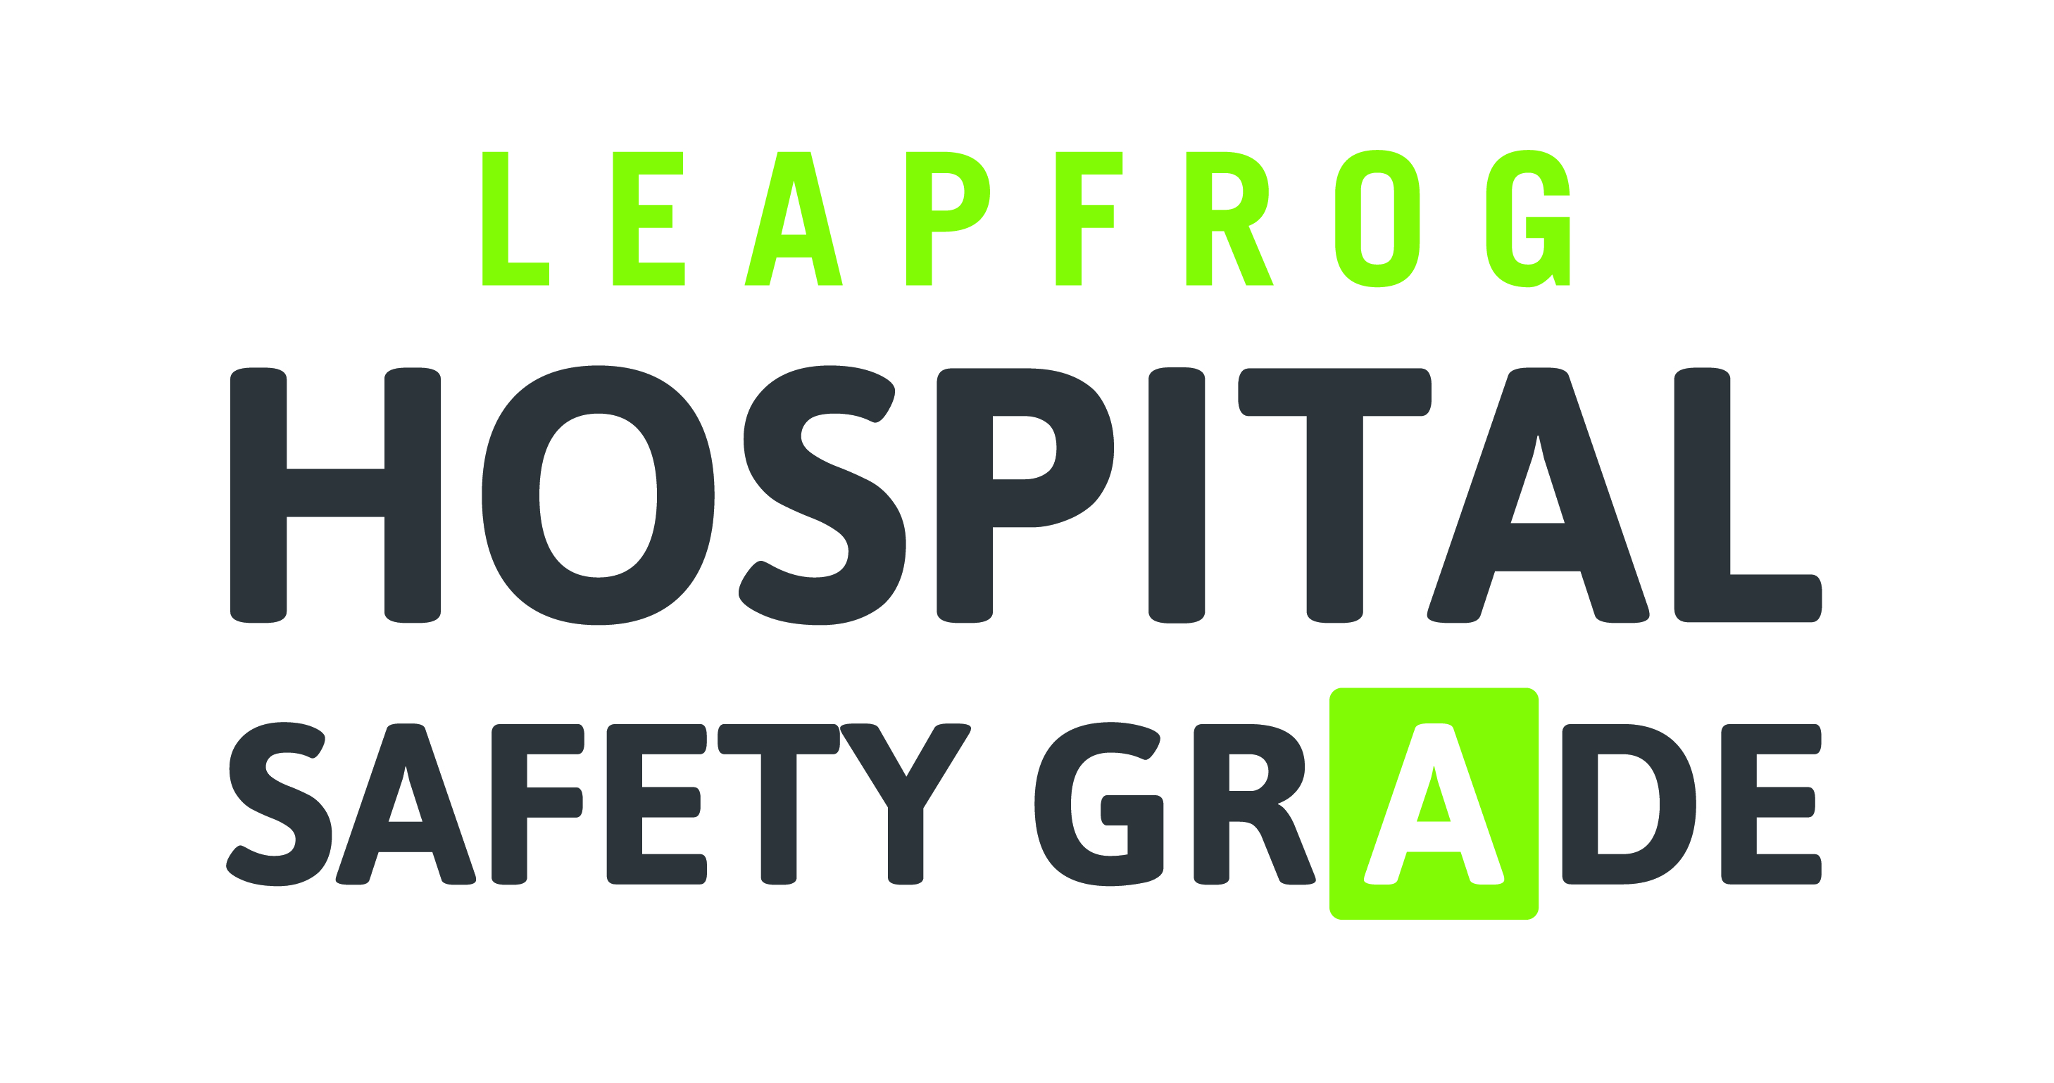

PURCHASER TOOLKIT
Newsletter Articles

“How Safe is Your Hospital?”
Do you know if you or your family would receive safe care if admitted to the local hospital? Now, it’s easy to find out. The Leapfrog Group, an employer-led nonprofit advocating for better hospital safety and quality, has publicly released a Leapfrog Hospital Safety Grade for over 2,600 general hospitals in the United States. Each letter grade—A, B, C, D or F—comes from expert analysis of the best and most up-to-date publicly available data on rates of errors, injuries, accidents, and infections. The Safety Grade is a consumer-friendly tool that can help you protect yourself and your family from harm during a hospital stay.
The Leapfrog Hospital Safety Grade is the first step forward for increased transparency and accountability at the places where people are the most vulnerable. You have a choice of where to receive care. And you deserve to be in the safest hospital possible.

“What is Patient Safety?”
Why is it important to consider a hospital’s safety when choosing a facility to receive care? Here’s a shocking statistic: as many as 440,000 deaths happen every year as a result of hospital errors and injuries. That’s more than 1,000 people today alone. And another study found that one out of every four Medicare recipients experiences injury, harm, or death when admitted to a hospital. Any other industry with an equally appalling safety record would immediately be regulated and shut down. Yet we are not holding our hospitals—the very place where Americans trust their health and lives—to the same standard.
Patient safety is an important element of an effective, efficient health care system. And since most errors can be prevented, hospitals need to work hard every day to protect their patients from harm.
The Leapfrog Hospital Safety Grade rates hospitals on how well they’re protecting their patients from problems like an infection due to improper handwashing, a sponge or instrument left inside the body, or a negative reaction due to a medication mix-up. And although errors still happen at “A” hospitals, seeking care at a hospital that has received an “A” grade could reduce your chance of experiencing harm.
“What is Safe Health care?”
Safe health care is care that helps, and does not hurt, the patient. Safe health care is delivered by high quality professionals who always strive to avoid surgical and medication errors, and to administer the right amount of treatment at the right time.
While many hospitals advertise that patient safety is very important, they do not always follow through with procedures and protocols to minimize risk. For example, many hospitals can perform safe surgeries, but not all hospitals ensure that the patient avoids an infection during recovery. Many hospitals encourage all staff members to wash their hands, but not all hospitals have policies to ensure that they do so. Many hospitals have world-renowned doctors and surgeons, but not all hospitals have a support team trained in working together to keep patients safe.
Although safety should be the biggest concern to hospital staff, there are significant differences in how well hospitals protect their patients from errors, injuries, accidents, and infections across the country.
The Leapfrog Hospital Safety Grade presents an opportunity to bring awareness to the importance of safe care in your area. It is the first step forward in improving transparency between hospitals and the public, helping health care consumers choose a safe hospital, and in beginning to demand that hospitals improve their safety record. As consumers use the Leapfrog Hospital Safety Grade more and more, we hope more hospitals will be compelled to improve their safety and participate in meaningful public reporting.

“What is the Leapfrog Hospital Safety Grade?”
The Leapfrog Hospital Safety Grade is a free public tool that grades hospitals on how well they protect their patients from errors, injuries, accidents, and infections. Each letter score—A, B, C, D, or F—comes from expert analysis of the best and most up-to-date publicly available safety performance data. This data has been translated into a consumer-friendly format so that the general public can use the information to protect themselves during a hospital stay. The Leapfrog Hospital Safety Grade is the first of its kind, and is designed to empower consumers to make informed choices about their care.
The goal of the Leapfrog Hospital Safety Grade is to reduce the approximately 440,000 yearly deaths that occur from hospital errors and injuries. It was created and is administered by The Leapfrog Group, an independent, national nonprofit organization founded more than a decade ago by the nation’s leading employers and private health care experts. The Leapfrog Group strives to make giant “leaps” forward in the safety, quality and affordability of health care in the U.S. by promoting transparency and empowering patients and employers to make a difference in their own communities.
“How to use the Leapfrog Hospital Safety Grade”
The Leapfrog Hospital Safety Grade allows patients to easily compare the safety of over 2,600 hospitals across the country. Safety should be the first and most important factor when choosing where to receive care. If patients are not safe, it doesn’t matter if the hospital has the best reputation, the latest equipment, or the most renowned specialists.
You can use the Leapfrog Hospital Safety Grade website to research the safest hospitals in your area in case of an emergency, or to select a hospital for a planned procedure, like a knee replacement or for giving birth.
To use the Leapfrog Hospital Safety Grade, visit www.hospitalsafetygrade.org or download the free mobile app. You can look up specific hospitals by name, or look up a state or zip code to see the Safety Grades of all the general hospitals in the area. Clicking on a hospital will bring up its overall grade, and its specific scores on 30 different safety measures.
If your local hospital rates below an “A,” we encourage you to talk with your doctor at that hospital and urge them to improve their safety. And if there are no safe hospitals in your area, use these Safety Grades to start a conversation with hospital leadership and local policymakers about hospital safety.

“What You Can Do to Stay Safe in the Hospital”
At some point, most of us will visit the hospital for medical treatment. To stay safe in the hospital, you need to take safety into your own hands. Use the Leapfrog Hospital Safety Grade to research and compare hospitals in your area. Then, gather important information before your hospital visit, such as the qualifications and expertise of your physician or surgeon. Stick to trusted Internet sources that provide up-to-date information that is backed by medical research. Check out the “What You Can Do to Stay Safe” section of the website for more resources.
At the hospital, be sure to share with your doctor all the medications you are currently taking. Bring a list of questions with you, and do not be embarrassed to ask the health care team if you are at all confused about any tests, procedures, or medications. Take notes about your care, including instructions on new medications so that you can remember all important information after you leave the hospital. Consider bringing a trusted relative or friend to the hospital with you.
Remember, as the patient, you are a vital part of the health care team. Throughout your time at the hospital, stay vigilant and actively involved in your care.
You have a choice of where to receive care. And you deserve to be in the safest hospital possible.

