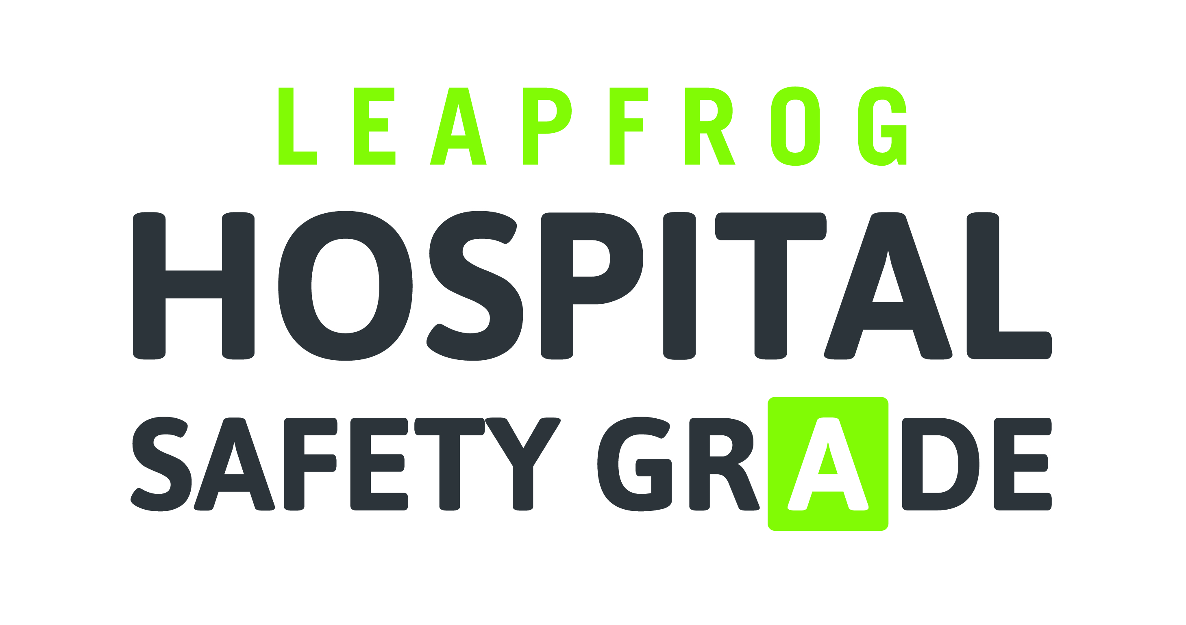

PURCHASER TOOLKIT
Key Talking Points on the Leapfrog Hospital Safety Grade
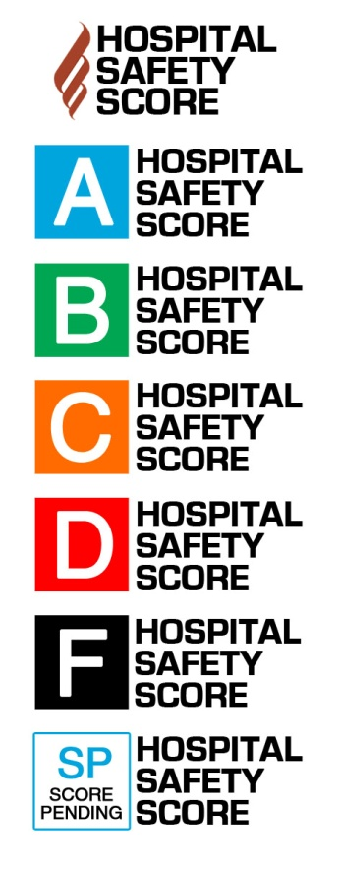

What is the Leapfrog Hospital Safety Grade?
The Leapfrog Hospital Safety Grade is an employer-driven initiative to score hospitals on how safe they are for patients. Each A, B, C, D or F grade comes from expert analysis of publicly available data consumers can use to protect themselves and their families from harm or death during a hospital stay. Visit www.hospitalsafetygrade.org to look up hospitals in your community and select the safest hospital for you and your family.

Is my hospital safe?
Approximately 440,000 people die every year because of a preventable hospital error. Over a decade ago, in response to this silent epidemic, employers like us came together to form an organization called The Leapfrog Group. We believe that hospitals should publicly report their safety and quality, so our employees and their families have good information to make decisions about their health care.

We are proud to share that Leapfrog reports the Leapfrog Hospital Safety Grade, rating over 2,500 hospitals on how safe they are; meaning, how well they protect patients from errors, injuries, accidents, and infections.

Who is The Leapfrog Group and why are they releasing this Leapfrog Hospital Safety Grade?
The Leapfrog Group—and all of the employers like us involved with its mission—seeks to raise public awareness of the safety of hospitals in communities across the country. By grading hospitals on safety performance, Leapfrog empowers our employees and the public to choose the safest hospital. We are proud to stand with Leapfrog on this groundbreaking initiative, and we’re happy to offer our employees the ability to analyze their hospitals’ safety.

We are also very active in our local business coalition, [Insert name of local business coalition on health]. Thanks to the efforts of employers and coalitions like us across the country, this sort of easy-to-use, patient-friendly data is now available. We will continue to advocate for improvements in hospital safety and quality, as well as to encourage that all hospitals publicly disclose information on safety and quality so that you can make the most informed decision on where to seek care.

What should I do if my local hospital didn’t get a good grade on the Leapfrog Hospital Safety Grade?
The Leapfrog Hospital Safety Grade is one tool that you should use in selecting a hospital. It is important to talk with your doctor about what hospital is best for you and your family. You should never refuse care in an emergency because of the Leapfrog Hospital Safety Grade, but it is a good idea to research your local hospitals in advance so that you are prepared if an emergency does arise.

How can I make sure my family and I are staying safe in the hospital?
Even when receiving care at an A hospital, it is important to stay vigilant and take action to protect yourself. Be prepared for your hospital stay by doing things like researching your hospital in advance, giving your doctors lists of your medications and all your medical records, and following checklists of steps to take in order to stay safe in the hospital. Visit the Leapfrog Hospital Safety Grade website for more tips on staying safe from harm while receiving hospital care.

