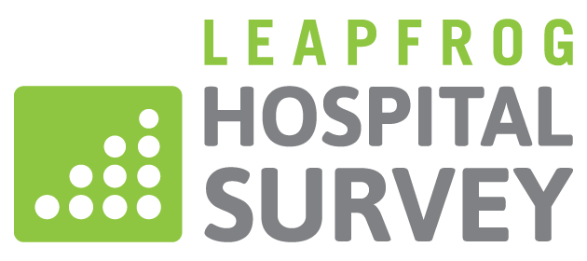

PURCHASER TOOLKIT
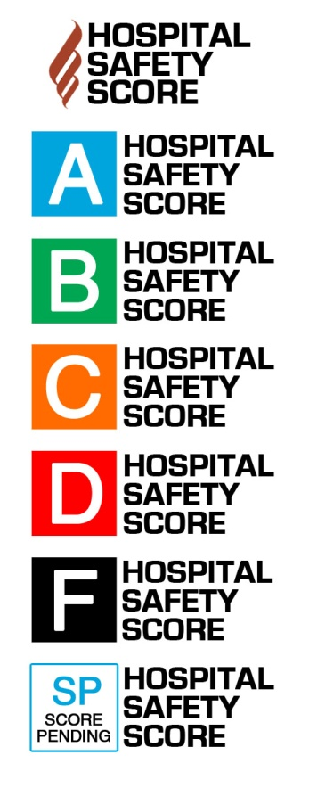
Template Email for Employers to Send to Hospitals

[YOUR LETTERHEAD]

[Date]
[Prefix] [First] [Last]
Chief Executive Officer
[Facility Name]
[Street Address]
[City, State, Zip]

Dear [Hospital CEO Name],
I am writing directly from [Employer] to urge your hospital to complete the annual Leapfrog Hospital Survey. Representing [XX covered lives] in [geographic area], one of the highest priorities for us as an employer is increasing transparency from providers in order to ensure our employees are receiving the best care and we are achieving value from our investment in health care benefits. The cornerstone of this process is public reporting of hospital performance data. The Leapfrog Hospital Survey has established itself as one of the most effective tools for addressing and reporting key measures of patient safety, quality, and resource use.
We are deeply concerned that your hospital has chosen to not complete this year’s Leapfrog Hospital Survey. The deadline for Survey completion is November 30. By submitting a completed Survey, your hospital’s performance will be included in the national results released and posted on Leapfrog’s website, www.leapfroggroup.org/compare. Health plans and other employers in addition to our company use these results to make informed decisions about plan structure and benefits. If your hospital does not complete the survey by November 30th, you will continue to be publicly reported as “Declined to Respond.”
Our company uses the data hospitals supply to the Leapfrog Hospital Survey in several ways:
      - List different activities of employer related to Leapfrog reporting

Already this year, over 2,000 hospitals nationwide have completed the Leapfrog Hospital Survey in response to our and other employers’ requests for increased transparency. It is very important to us that your hospital demonstrate a similar commitment to transparency and excellence in quality and safety by completing a Leapfrog Hospital Survey.
Thank you once again for your investment in improving the health of our employees.

Sincerely,

[Employer Representative]

